

Media support:

Jill Rick

+1 262-337-0854

[jill.rick@global.komatsu](mailto:jill.rick@global.komatsu)

Shawn-Laree O’Neil

+1 773-802-0377

[shawn-laree.o’neil@global.komatsu](mailto:shawn-laree.o’neil@global.komatsu)

Komatsu’s HB365LC-3 hybrid excavator among environmentally friendly solutions featured at CONEXPO-CON/AGG 2023

**March 14, 2023** — To demonstrate how they can help customers manage energy transitions and increase efficiencies to help reduce fuel burn and emissions, [Komatsu](https://www.komatsu.com/?utm_source=Website&utm_medium=PressRelease&utm_campaign=ConExpo2023&utm_content=hb365lc-3) will showcase its [HB365LC-3](https://www.komatsu.com/products/excavators/large-excavators/hb365lc-3/?utm_source=Komatsu&utm_medium=PressRelease&utm_campaign=ConExpo2023&utm_content=hb365-3) hybrid excavator ​at CONEXPO-CON/AGG 2023. In booth W42044, visitors to the show can learn more about the 269-HP machine and how this hybrid excavator is designed to provide high production and efficiency with low fuel consumption.

Engineered for productivity and performance, this hybrid excavator’s generator/motor system provides an additional 70 HP on demand and up to 15% more productivity in P mode. 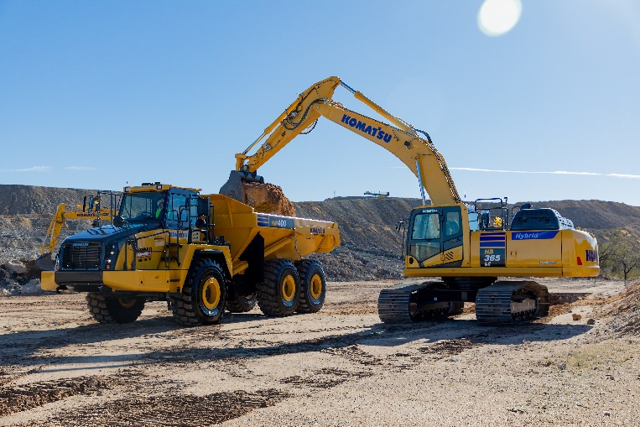Offering environmentally friendly operation, the HB365LC-3 can deliver up to 20% greater fuel efficiency but with 20% lower CO2 emissions. With thousands of hybrids working globally, the HB365LC-3 offers comfortable operation thanks to its 2dB interior/exterior sound reduction and comes with a 7-year, 15,000-hour transferable warranty on hybrid components.

Komatsu's HB365LC-3 is designed to provide high production and efficiency with low fuel consumption.

The HB365LC-3 will be displayed at CONEXPO with Smart Construction Retrofit, a guidance kit that gives operators in the field and managers in the office access to 3D design and payload data to help drive accuracy, control load volumes and improve operations. Easily installed by a local Komatsu distributor, these low-cost kits can reduce work for operators, as they no longer have to set up a laser or bench every time the machine moves. The global navigation satellite system (GNSS) can determine where a machine is on the job site and what the target grade is to help reduce handling and reworking material.

With the right products, latest technologies, actionable data and dealer support, Komatsu and its customers can create value together. To learn more, visit Komatsu at CONEXPO 2023 at booth W42044. Additional products and solutions will be highlighted at neighboring booths for Hensley Industries (W42028), and Montabert (W42229), both Komatsu subsidiaries.

**About Komatsu**

Komatsu develops and supplies technologies, equipment and services for the construction, mining, forklift, industrial and forestry markets. For a century, the company has been creating value for its customers through manufacturing and technology innovation, partnering with others to empower a sustainable future where people, business and the planet thrive together. Front-line industries worldwide use Komatsu solutions to develop modern infrastructure, extract fundamental minerals, maintain forests and create consumer products. The company's global service and distributor networks support customer operations to enhance safety and productivity while optimizing performance. To learn more, visit [www.komatsu.com](http://www.komatsu.com)

# # #

* All comparisons are to the PC360LC-11