

Media support:

Jill Rick

+1 262-337-0854

[jill.rick@global.komatsu](mailto:jill.rick@global.komatsu)

Shawn-Laree O’Neil

+1 773-802-0377

[shawn-laree.o’neil@global.komatsu](mailto:shawn-laree.o’neil@global.komatsu)

Komatsu’s HM400-5 articulated truck

will be on display at CONEXPO-CON/AGG 2023

*Offers productive performance for operators of all experience levels*

**March 14, 2023** — For job sites where roads are not well-established, or may not exist, the [Komatsu](https://www.komatsu.com/?utm_source=Komatsu&utm_medium=PressRelease&utm_campaign=ConExpo2023&utm_content=hm-400-5) HM400-5 articulated truck is engineered to move material across challenging and adverse terrain. On display at CONEXPO-CON/AGG 2023 in booth W42044, the [HM400-5](https://www.komatsu.com/products/trucks/articulated-trucks/hm400-5/?utm_source=Komatsu&utm_medium=PressRelease&utm_campaign=ConExpo2023&utm_content=hm400-5) is designed to deliver productive, consistent performance for operators of all experience levels.

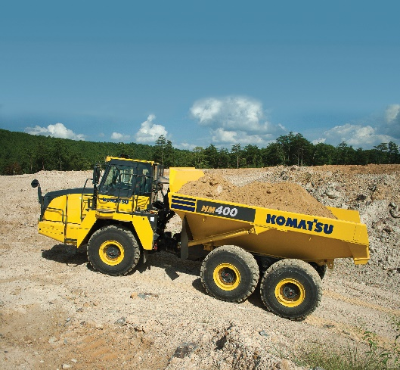The truck is well-known in the industry for its reliability and long-term durability. To support growing demand, Komatsu recently began assembling HM400-5 trucks at its factory in Chattanooga, Tennessee. The trucks are now being produced at both that plant and at Komatsu’s plant in Ibaraki, Japan.

Komatsu recently started producing its HM400-5 trucks at the company's factory in Chattanooga, Tennessee.

The 466-HP HM400-5 features the Komatsu Traction Control System (KTCS), designed to offer exceptional performance in poor underfoot conditions. The traction system requires no operator input and functions automatically by monitoring and adjusting to changing conditions, without sacrificing steering performance.

The truck’s standard payload meter system is designed to promote optimized loading and production. The loaded material weight can be viewed in the cab on a monitor, from the loading tool via cab-mounted external display lamps, or through Komtrax, the company’s telemetric technology. External lamps on the truck illuminate green, yellow or red as the payload increases to help prevent under- and overloaded haul cycles.

The truck’s heated, air suspension seat is designed to enhance operator comfort and reduce fatigue​. The front and rear axle hydro-pneumatic suspensions mounted on a dynamic equalizer structure assist in providing a smooth ride.

With the right products, latest technologies, actionable data and dealer support, Komatsu and its customers can create value together. To learn more, visit Komatsu at CONEXPO 2023 at booth W42044. Additional products and solutions will be highlighted at neighboring booths for Hensley Industries (W42028), and Montabert (W42229), both Komatsu subsidiaries.

**About Komatsu**

Komatsu develops and supplies technologies, equipment and services for the construction, mining, forklift, industrial and forestry markets. For a century, the company has been creating value for its customers through manufacturing and technology innovation, partnering with others to empower a sustainable future where people, business and the planet thrive together. Front-line industries worldwide use Komatsu solutions to develop modern infrastructure, extract fundamental minerals, maintain forests and create consumer products. The company's global service and distributor networks support customer operations to enhance safety and productivity while optimizing performance. To learn more, visit [www.komatsu.com](http://www.komatsu.com)

# # #