

Media support:

Jill Rick

+1 262-337-0854

[jill.rick@global.komatsu](mailto:jill.rick@global.komatsu)

Shawn-Laree O’Neil

+1 773-802-0377

[shawn-laree.o’neil@global.komatsu](mailto:shawn-laree.o’neil@global.komatsu)

Komatsu’s intelligent Machine Control 2.0 dozers will be featured

at CONEXPO-CON/AGG 2023

*iMC technology can streamline onboarding and help with workforce optimization*

**March 14, 2023** — Productivity is key to job site success. And while each business is unique, the need for predictability is universal, which is why [Komatsu](https://www.komatsu.com/?utm_source=Komatsu&utm_medium=PressRelease&utm_campaign=ConExpo2023&utm_content=dozers_d39pxi_d51pxi-24_d71pxi-24_) will feature three of its [intelligent Machine Control 2.0](https://www.komatsu.com/site-optimization/smart-construction/intelligent-machine-control/?utm_source=Website&utm_medium=PressRelease&utm_campaign=ConExpo2023&utm_content=intelligent-dozers_d71pxi24_d51pxi24_d39pxi24?utm_source=Komatsu&utm_medium=PressRelease&utm_campaign=ConExpo2023&utm_content=imc-dozers) (iMC 2.0) dozers at CONEXPO-CON/AGG 2023 in booth W42044: D39PXi-24, D51PXi-24 and the D71PXi-24.

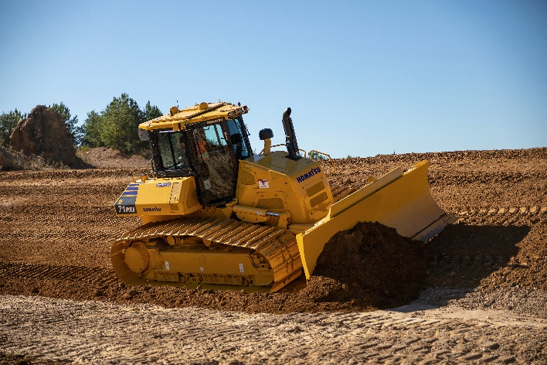Today, when many companies are struggling to find experienced workers or train existing ones, on-machine technology like iMC 2.0 can streamline onboarding and help close the operator skills gap by allowing automation throughout the dozing process. Komatsu’s iMC 2.0 dozers help maximize efficiencies so operators — even newer operators — can deliver more precise production.

Komatsu's intelligent Machine Control-equipped dozers can help operators deliver more precise work.

First introduced by Komatsu in 2013, iMC continues to evolve, offering more automated functions for increased precision and reduced waste. Intelligent machines help reduce emissions per amount of material moved because it’s “moved right” the first time.

Incorporating a host of advanced, proprietary machine technology, the Komatsu D39PXi-24 (105 HP), D51PXi-24 (131 HP) and the D71PXi-24 (237 HP) equipped with Komatsu’s iMC 2.0 offer the following benefits:

**Learns as it works**

With *proactive dozing control*, even less experienced operators can automatically cut/strip from existing terrain. The dozer measures the terrain it tracks over and uses that data to plan the next pass. Productivity can improve by up to 60% compared to conventional grading methods.

**Spreads fill material automatically**

*Lift layer control* automatically lets operators spread fill from existing terrain with the press of a button**.** The dozer measures the terrain it tracks over and uses the data it gathers to plan the next passfor up to double production with consistent layers for compaction quality.

**Levels material even during rough dozing**

*Tilt steering control* automatically tilts the blade to maintain straight travel during rough dozing, which can help reduce operator steering input by up to 80%.

With automatic dozing, rough cut to finish grade, iMC-equipped Komatsu dozers help make every pass count, for superior production compared to traditional aftermarket systems.

With the right products, latest technologies, actionable data and dealer support, Komatsu and its customers can create value together. To learn more, visit Komatsu at CONEXPO 2023 at booth W42044. Additional products and solutions will be highlighted at neighboring booths for Hensley Industries (W42028), and Montabert (W42229), both Komatsu subsidiaries.

**About Komatsu**

Komatsu develops and supplies technologies, equipment and services for the construction, mining, forklift, industrial and forestry markets. For a century, the company has been creating value for its customers through manufacturing and technology innovation, partnering with others to empower a sustainable future where people, business and the planet thrive together. Front-line industries worldwide use Komatsu solutions to develop modern infrastructure, extract fundamental minerals, maintain forests and create consumer products. The company's global service and distributor networks support customer operations to enhance safety and productivity while optimizing performance. To learn more, visit [www.komatsu.com](http://www.komatsu.com)

# # #