

Media support:

Jill Rick

+1 262-337-0854

[jill.rick@global.komatsu](mailto:jill.rick@global.komatsu)

Shawn-Laree O’Neil

+1 773-802-0377

[shawn-laree.o’neil@global.komatsu](mailto:shawn-laree.o’neil@global.komatsu)

Rebranded Komatsu MVT-II 600 sizer

to debut at company’s CONEXPO-CON/AGG 2023 booth

**March 14, 2023** — To support the company's One Komatsu global strategy and the integration of their legacy companies into the [Komatsu](https://www.komatsu.com/?utm_source=Komatsu&utm_medium=PressRelease&utm_campaign=ConExpo2023&utm_content=crushing-rebrand_mvt-2-600_quarry) brand, sizers, reclaim feeders and surface feeder breakers will be rebranded to Komatsu natural yellow (from Joy orange). Displayed in the Komatsu booth (W42044) at CONEXPO-CON/AGG 2023 will be the newly rebranded yellow [MVT-II 600 sizer](https://www.komatsu.com/en/products/crushing/sizers/mvt-ii-600/?utm_source=Komatsu&utm_medium=PressRelease&utm_campaign=ConExpo2023&utm_content=MTV-II600).

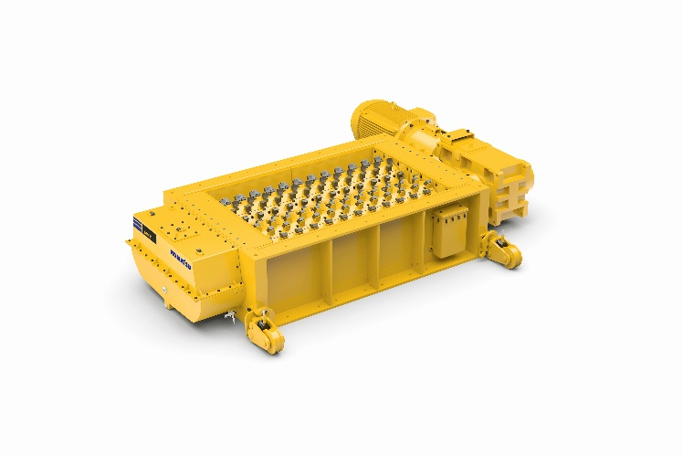For waste reduction in the quarry and cement production process, the Komatsu MVT-II 600 sizer uses matched velocity technology (MVT) to generate far less fines in product and help minimize waste production and disposal costs. The process uses tension — rather than compression — which can save significant energy. Timed center-sizing rolls enable teeth to mesh together and control product size in three dimensions.

Komatsu's newly rebranded MVT-II 600 sizer will be on display at CONEXPO.

The no-clog crushing of the MVT-II 600 can consistently crush a combination of hard abrasive minerals and wet sticky material. Engineered for lower cost of ownership, the MVT-II 600 has replaceable bolt-on roll wear segments and durable pick technology. Shaft assemblies include cast wear segments with replaceable teeth for extended life.

The MVT-II sizer can be installed where many other crushing technologies would not fit and at a potentially lower cost. Ideal for mobile or underground applications with a small machine envelope, secondary sizers can often be installed between conveyor transfer points to reconcile material handling issues. The sizer can potentially reduce the number of crushing/dump stations required and can work with very large lump sizes to increase crushing ratios.

With the right products, latest technologies, actionable data and dealer support, Komatsu and its customers can create value together. To learn more, visit Komatsu at CONEXPO 2023 at booth W42044. Additional products and solutions will be highlighted at neighboring booths for Hensley Industries (W42028), and Montabert (W42229), both Komatsu subsidiaries.

**About Komatsu**

Komatsu develops and supplies technologies, equipment and services for the construction, mining, forklift, industrial and forestry markets. For a century, the company has been creating value for its customers through manufacturing and technology innovation, partnering with others to empower a sustainable future where people, business and the planet thrive together. Front-line industries worldwide use Komatsu solutions to develop modern infrastructure, extract fundamental minerals, maintain forests and create consumer products. The company's global service and distributor networks support customer operations to enhance safety and productivity while optimizing performance. To learn more, visit [www.komatsu.com](http://www.komatsu.com)

# # #