

Media support:

Jill Rick

+1 262-337-0854

[jill.rick@global.komatsu](mailto:jill.rick@global.komatsu)

Shawn-Laree O’Neil

+1 773-802-0377

[shawn-laree.o’neil@global.komatsu](mailto:shawn-laree.o’neil@global.komatsu)

At CONEXPO-CON/AGG 2023 Komatsu features

its 20-ton PC210LCE electric excavator

**March 14, 2023** — To help customers reduce their carbon footprint and plan for implementing sustainable solutions through electrification, at CONEXPO-CON/AGG 2023 [Komatsu](https://www.komatsu.com/?utm_source=Website&utm_medium=PressRelease&utm_campaign=ConExpo2023&utm_content=pc-210e) will feature its 20-ton [PC210LCE](https://www.komatsu.com/events/conexpo/?utm_source=Komatsu&utm_medium=PressRelease&utm_campaign=ConExpo2023&utm_content=pc210lce) electric excavator.

First displayed last fall at bauma, the PC210LCE was created for construction businesses that need a high-performance machine while cutting fuel costs. Featuring lithium-ion battery technology developed by Proterra, the excavator has 451 kWh of battery capacity, designed for up to 8 hours of operating time.

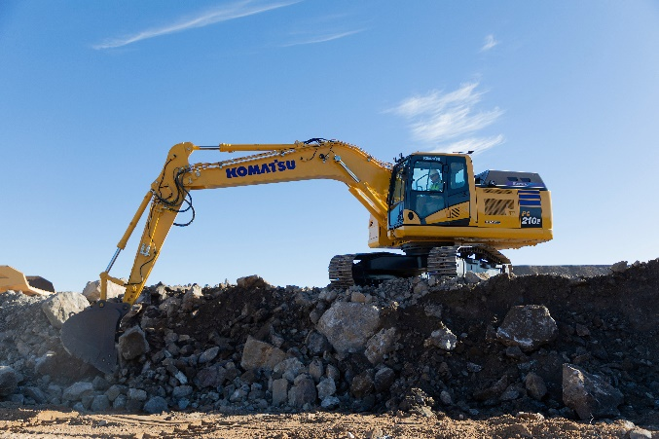Designed to reduce operator fatigue with less noise, exhaust emissions and zero engine vibration, the PC210LCE is ideal for use in urban areas and indoor environments. The low operating noise levels of the PC210LCE can allow for nighttime construction work both indoors and out.

Komatsu's PC210LCE electric excavator features lithium-ion battery technology developed by Proterra.

Coming soon to North America, the PC210LCE supports Komatsu's global sustainability targets of 50% reduction in CO2 emissions by 2030 and complete carbon neutrality by 2050. Komatsu is committed to helping customers manage energy transitions and increase efficiencies to help reduce fuel burn and emissions. ​

At the show, the PC210LCE will be displayed with Smart Construction Retrofit, an affordable guidance kit that gives operators in the field and managers in the office access to both 2D and 3D design and payload data to help drive accuracy, control load volumes and improve operations. Easily installed by a local Komatsu distributor, this technology upgrade is designed to improve grading performance and help drive productivity and profitability.

With the right products, latest technologies, actionable data and dealer support, Komatsu and its customers can create value together. To learn more, visit Komatsu at CONEXPO 2023 at booth W42044. Additional products and solutions will be highlighted at neighboring booths for Hensley Industries (W42028), and Montabert (W42229), both Komatsu subsidiaries.

**About Komatsu**

Komatsu develops and supplies technologies, equipment and services for the construction, mining, forklift, industrial and forestry markets. For a century, the company has been creating value for its customers through manufacturing and technology innovation, partnering with others to empower a sustainable future where people, business and the planet thrive together. Front-line industries worldwide use Komatsu solutions to develop modern infrastructure, extract fundamental minerals, maintain forests and create consumer products. The company's global service and distributor networks support customer operations to enhance safety and productivity while optimizing performance.To learn more, visit [www.komatsu.com](http://www.komatsu.com)

# # #