

Media support:

Jill Rick

+1 262-337-0854

[jill.rick@global.komatsu](mailto:jill.rick@global.komatsu)

Shawn-Laree O’Neil

+1 773-802-0377

[shawn-laree.o’neil@global.komatsu](mailto:shawn-laree.o’neil@global.komatsu)

Komatsu’s PC230F-11 forestry processor will be featured at CONEXPO-CON/AGG 2023

*Powerful and maneuverable processor can delimb, cut and stack felled timber*

**March 14, 2023** — Forestry crews need equipment that can deliver exceptional performance in difficult environments. [Komatsu](https://www.komatsu.com/?utm_source=Komatsu&utm_medium=PressRelease&utm_campaign=ConExpo2023&utm_content=forestry_pc230f-11)’s robust, dependable and fuel-efficient [PC230F-11](https://www.komatsu.com/products/forestry/swing-machines/pc230f-11/?utm_source=Komatsu&utm_medium=PressRelease&utm_campaign=ConExpo2023&utm_content=pc210lce) processor can help control downtime and drive productivity and will be featured in the company’s booth (W42044) at CONEXPO-CON/AGG 2023.

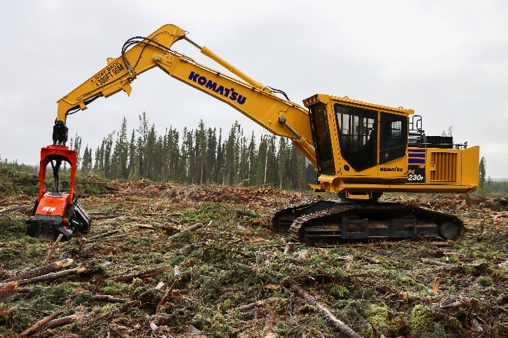Purpose-built for processing applications, the 197-HP PC230F-11 has a rugged design, high and wide undercarriage, a powerful swing motor and is designed to withstand high-debris conditions. The robust wide-fin radiator is covered by heavy-duty forestry screens, and a variable pitch reversing fan helps improve airflow.

Komatsu's PC230F-11 processor is purpose-built for logging applications.

With a powerful swing system and a large swing circle, large trees can be moved easily with the PC230F-11. Its reach of up to 29.3 feet (8,951 mm), and excellent maneuverability help drive productivity.

The Komatsu SAA6D107E-3 Tier 4 Final engine is more fuel efficient than the prior engine. Thanks to proprietary Komatsu engine technology, the larger size-class (PC290LL-11) factory-installed engine also powers performance.

Operators can adjust quickly to a sudden change in load weight without compromising productivity with the Auto Power Max feature. It automatically senses the difference and reacts with an 8.5-second burst of additional horsepower to help pull the trees through during the delimbing process. The PC230F-11 is backed by excellent service, easy access to parts and a robust warranty.

With the right products, latest technologies, actionable data and dealer support, Komatsu and its customers can create value together. To learn more, visit Komatsu at CONEXPO 2023 at booth W42044. Additional products and solutions will be highlighted at neighboring booths for Hensley Industries (W42028), and Montabert (W42229), both Komatsu subsidiaries.

**About Komatsu**

Komatsu develops and supplies technologies, equipment and services for the construction, mining, forklift, industrial and forestry markets. For a century, the company has been creating value for its customers through manufacturing and technology innovation, partnering with others to empower a sustainable future where people, business and the planet thrive together. Front-line industries worldwide use Komatsu solutions to develop modern infrastructure, extract fundamental minerals, maintain forests and create consumer products. The company's global service and distributor networks support customer operations to enhance safety and productivity while optimizing performance.To learn more, visit [www.komatsu.com](http://www.komatsu.com)

# # #