

Media support:

Jill Rick

+1 262-337-0854

[jill.rick@global.komatsu](mailto:jill.rick@global.komatsu)

Shawn-Laree O’Neil

+1 773-802-0377

[shawn-laree.o’neil@global.komatsu](mailto:shawn-laree.o’neil@global.komatsu)

Komatsu’s WA475-10 WH wheel loader/waste handler

will be featured at CONEXPO-CON/AGG 2023

*Customizable waste guarding packages designed to meet demanding environments*

**March 14, 2023** — To meet the challenges of waste management, Komatsu’s [WA475-10 WH](https://www.komatsu.com/products/wheel-loaders/large-wheel-loaders/wa475-10-wh/?utm_source=Komatsu&utm_medium=PressRelease&utm_campaign=ConExpo2023&utm_content=wa475-10wh) is a productive wheel loader with customizable waste guarding packages and tire options that can be configured for specific waste or scrap handling applications.​ On display in [Komatsu](https://www.komatsu.com/?utm_source=Komatsu&utm_medium=PressRelease&utm_campaign=ConExpo2023&utm_content=waste_wa475-10) booth W42044 at CONEXPO/CON/AGG 2023, the WA475-10 WH was developed based on customer feedback and incorporates an improved pressurized cab, enhanced machine visibility and increased ease of operation with features like independent work equipment control.

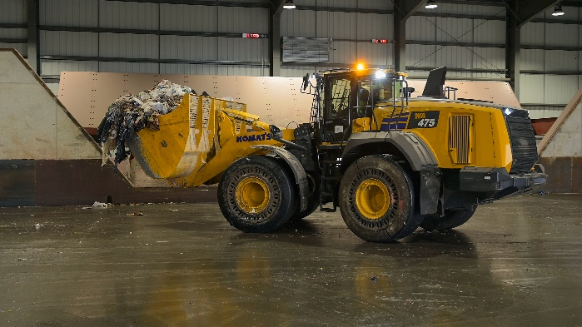In addition to the customizable waste guarding package, optional joystick steering for easier maneuverability and improved visibility is also available. The model includes the innovative next-gen Komatsu hydraulic mechanical transmission (K-HMT), improving fuel efficiency (by up to 30%) and simplifying operation.​

Komatsu's WA475-10 WH is designed to meet the challenging needs of the waste management industry.

To protect vital machine parts, improve protection from airborne debris and reduce wear on components for the WA475-10 WH:

* The front and rear frame underguard protects the engine oil pan, oil drain and fuel tank drain and reduces debris buildup, while shielding powertrain and hydraulic components.
* The fuel tank guard encloses the exposed surfaces of the fuel tank to minimize damage and transfers impact forces into the rear frame and counterweight.
* The axle seal guards are adjustable to ensure fit and reduce debris build up around shaft and seals.
* The cooling screens increase effective open area for airflow, while reducing the amount of debris reaching the coolers.
* The bucket cylinder guard protects the bucket cylinder rod from falling debris.
* The front window guard provides an additional layer of protection from large debris for the operator and window, while guards on the front and rear lights help protect those from damage.

With the right products, latest technologies, actionable data and dealer support, Komatsu and its customers can create value together. To learn more, visit Komatsu at CONEXPO 2023 at booth W42044. Additional products and solutions will be highlighted at neighboring booths for Hensley Industries (W42028), and Montabert (W42229), both Komatsu subsidiaries.

**About Komatsu**

Komatsu develops and supplies technologies, equipment and services for the construction, mining, forklift, industrial and forestry markets. For a century, the company has been creating value for its customers through manufacturing and technology innovation, partnering with others to empower a sustainable future where people, business and the planet thrive together. Front-line industries worldwide use Komatsu solutions to develop modern infrastructure, extract fundamental minerals, maintain forests and create consumer products. The company's global service and distributor networks support customer operations to enhance safety and productivity while optimizing performance. To learn more, visit [www.komatsu.com](http://www.komatsu.com)

# # #

*All comparisons are to the previous Komatsu model unless otherwise stated.