MST Global technology solutions

*Media fact sheet*

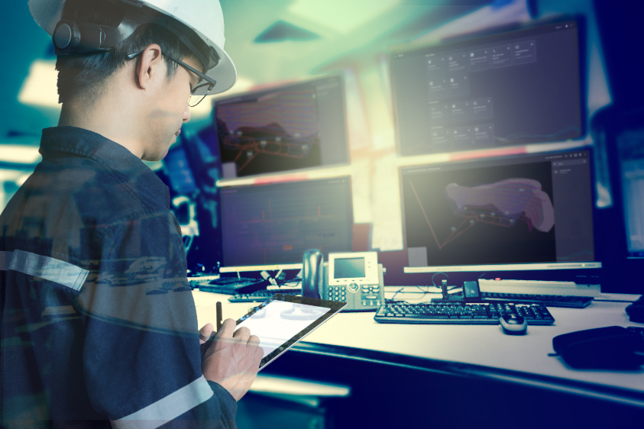

MST’s scalable enterprise platform provides a single, unifying portal for software and user interaction across all modules.

**HELIX 3D Connect** provides one place to view multiple mines, offering an overview of the status of each operation. This includes personnel and vehicle tracking and network communications. Users can create personalized views in the context of the mine model to see both above and below ground.

**HELIX IoT** offers an end-to-end low-power, wide-area network protocol (LoRaWAN) sensor monitoring solution. Flexible and scalable with extensive coverage area and interoperability across devices and networks, it supports a wide range of LoRa sensors to address many mining operational use cases. With information processed and displayed on individual dashboards for each sensor type, notifications can be configured for sensor data thresholds providing visibility and awareness in critical situations.

The **HELIX Automation** platform enables simple automation of systems. By integrating simple process control into one software platform, HELIX can help improve safety and efficiency across operations. Data can be fed from a variety of systems into a central location, and users can set up unique rules for their individual needs using the geospatial information from 3D mapping and tracking data.

Developed to address common mining challenges such as communication with operators, equipment position tracking, work progress tracking and face status visibility, **HELIX Dispatch** offers fleet management from the production face to surface and points in between. It offers real-time automated production tracking, task management and time tracking.

**MST’s situational awareness system** is designed to reduce the risk of vehicle/person and vehicle/vehicle collisions by providing an early warning indication of the number of vehicles and personnel present in the vicinity. It’s a powerful vehicle intelligence platform (VIP) unit that controls the detection zone and reads tag signals, and it can also act as a wireless bridge to connect to AXON networks if required.

Unaffected by low-light environments, rain, dust or fog, **MST's Proximity Detection system** provides a comprehensive, real-time proximity safety solution for personnel and vehicles in underground or surface mines, as well as industrial and construction sites.  Designed for accuracy and reliability, the detection system uses low-frequency magnetics to ensure a repeatable detection range in a variety of environments. All events are logged and can be uploaded for auditing or reporting.

With an easy push-to-talk function and 30 configurable channels, **MST MinePhones** offer 72 hours of standby time and are designed for low-visibility environments and operators wearing gloves. Requiring Wi-Fi, these network-agnostic phones have functions like a traditional phone for calls and messaging, as well as an emergency man-down function, which allows for emergency broadcasts to be sent to all phones from the surface.

MST Global specializes in mining and tunneling technology designed for safety and productivity improvements. For 30 years they have produced innovative solutions to address the current and future needs of mining customers.