

**Media support:**

Jill Rick

+1 262-337-0854

[jill.rick@global.komatsu](mailto:jill.rick@global.komatsu)

Shawn-Laree O’Neil

+1 773-802-0377

[shawn-laree.o’neil@global.komatsu](mailto:shawn-laree.o’neil@global.komatsu)

Komatsu adds WX11 LHD to underground hard rock lineup

New machine engineered to drive productivity and lower TCO

**Feb. 28, 2024** — Komatsu is excited to introduce to the global market the new [WX11 LHD](https://www.komatsu.com/products/underground-hard-rock-haulage/lhd/wx11/?utm_source=Komatsu&utm_medium=PressRelease&utm_campaign=WX11LHD), a powerful, 11-tonne machine that offers best-in-class breakout force and best-in-class payload helping to maximize productivity and provide a lower total cost of ownership.

Komatsu's new WX11 LHD offers 8-10% more payload than competitor machines.

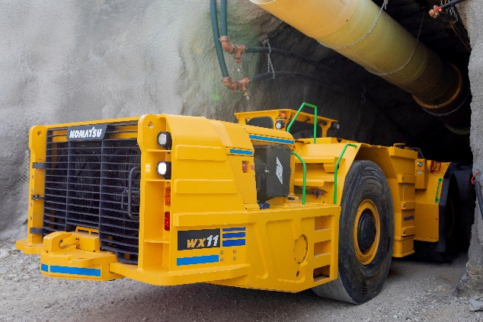The WX11 showcases Komatsu’s commitment to providing underground hard rock miners with an exceptional load, haul and dump solution, integrating next-generation data management capabilities, operator ergonomics, intuitive controls and compliance with EU Stage V emission requirements. As a new model within the Komatsu hard rock family of products, the WX11 is designed to be a class-leading LHD for all underground mine operators and contractors. With ease of operability, superior performance and ground-level maintenance position, the WX11 has several competitive edges in the 10-tonne LHD class.

Quick specs and features:

* Horsepower: 280 HP @ 2,000 rpm (209 kW @ 2,000 rpm)
* Operating weight: 77,750 lbs. (35,250 kg)
* Available engine certifications: Canmet, MSHA, EPA Tier 3/EU Stage IIIA and EPA Tier 4F/EU Stage V
* 11-tonne size provides a best-in-class payload boost (8-10% increase) above other machines in class
* New size provides best-in-class breakout force and outstanding operator visibility
* Adjustable ride control
* Onboard telemetry

The WX11 hosts many additional features specific to the platform:

* New heavy-duty hard rock Komatsu axles with SAHR brakes
* Komatsu cylinders and accumulators
* Swing-out radiator fan assemblies to support quick washdowns
* Optimized kinematics for superior breakout and tilt force
* All-new engineered structures to support the additional 10% payload capacity

“The WX11 is a game changer for hard rock miners. Developed through a close partnership between our experienced team and our longtime customers, this product reflects a shared commitment to design excellence,” said Ryan Karns, Director of LHD and Truck Products at Komatsu. “The WX11 is the LHD every miner will want to have in their operation.”

**About Komatsu**

Komatsu develops and supplies technologies, equipment and services for the construction, mining, forklift, industrial and forestry markets. For more than a century, the company has been creating value for its customers through manufacturing and technology innovation, partnering with others to empower a sustainable future where people, business and the planet thrive together. Front-line industries worldwide use Komatsu solutions to develop modern infrastructure, extract fundamental minerals, manage forests and create consumer products. The company's global service and distributor networks support customer operations to help enhance safety and promote productivity while working to optimize performance. Learn more at [www.komatsu.com](http://www.komatsu.com).

# # #