

Media support:

Jill Rick

+1 262-337-0854

[jill.rick@global.komatsu](mailto:jill.rick@global.komatsu)

Shawn-Laree O’Neil

+1 773-802-0377

[shawn-laree.o’neil@global.komatsu](mailto:shawn-laree.o’neil@global.komatsu)

To meet sustainability goals

Komatsu will showcase electric machines and battery technology at CONEXPO-CON/AGG 2023

**March 6, 2023** — For the sustainability of businesses and the planet, at CONEXPO/CON-AGG 2023, Komatsu will be showcasing machines and technology engineered to help customers reduce their carbon footprint​ and plan for implementing sustainable solutions, including electrification. In booth W42044, visitors to the show will find a variety of options designed to help manage energy transitions and increase efficiencies to help reduce fuel burn and emissions and make fleet management more efficient.​

***Electric excavators***

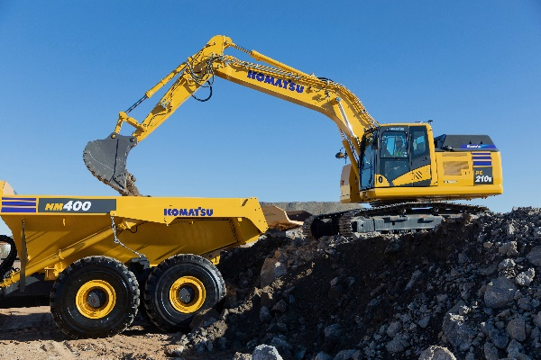Coming soon to North America and featured in the Komatsu booth will be the 20-ton **PC210LCE electric excavator**, first displayed last fall at Bauma. Featuring Proterra’s lithium-ion battery technology, the excavator has 451 kWh of battery capacity, for up to 8 hours of operating time*.

Komatsu's PC210LCE electric excavator features Proterra's lithium-ion battery technology.

*Operation of 5 to 9 hours in tests, depending on workload conditions.

For quiet and simpler operation without vibrations and zero emissions, the **PC30E electric mini excavator**​ fits the bill. Equipped with a 35-kWh battery and a 17.4 kW electric motor​, its batteries can be fast-charged.​ This electric mini-excavator is suitable for a diverse range of workplaces including operating indoors, urban construction, and landscaping.​

Komatsu will also feature its **PC01E electric micro excavator** powered by portable and swappable mobile batteries.​ Developed jointly with Honda, this new machine is designed for confined spaces in landscaping, agriculture and construction. Komatsu's vision for the swappable battery system is to scale up the technology for use in larger micro excavator models. ​

The PC210LCE, PC30E and PC01E will be available in select markets in 2023.

***Electric wheel loader concept***

With a chassis based on the Komatsu WA70 wheel loader, the WA Electric wheel loader concept machine was developed in partnership with Moog Inc. Utilizing an "intelligent electrification system,” this wheel loader features an electric traction motor, lift, tilt and steering cylinders, power electronics, system control computer, battery and battery management system. ​

***Battery technology and charging station advancements***

​To provide flexible charging solutions for varying applications and customer needs, Komatsu is exploring high-power-charging solutions and developing multiple power source options including batteries. Three types of charging infrastructure options will be on display at the company’s booth.

The **Komatsu Generation 2 charger** is well-suited to adapt to varying site conditions, stepping voltage up or down to meet charging needs. With an input range from 400-1140V and an output of 300-900V, it features a universal CCS (AC/DC) charge plug and it too is transportable.

Developed in partnership with Proterra, the **Proterra portable charging concept**​ is designed for use in “off grid” locations or where site power is inaccessible or unreliable.

The **Komatsu portable charging concept for mini-excavator,** exhibited as a charging solution concept for environments without a power supply, is compactly designed for easy transportation. In addition to charging mini-excavators, it can also be used to charge other electric equipment on the work site.

Komatsu's portable charging concept for mini-excavator is a concept designed for environments without a power supply.

***HB365LC-3 hybrid excavator***

Komatsu’s hybrid excavator is designed to provide high production and efficiency with low fuel consumption. Engineered for productivity with a Komatsu hybrid system that can provide an additional 70 Hp on demand​, the HB365LC-3 allows operators to be up to 15% more productive in power mode, while its environmentally friendly operation offers up to 20% more fuel efficiency and 20% less CO2 emissions when compared to the PC360LC-11. ​

Development of these hybrid and electric machines and charging stations moves Komatsu closer to its global sustainability target of a 50% reduction in CO2 emissions by 2030 and complete carbon neutrality by 2050.

***MVT-II 600***

To reduce waste in the quarry and cement production process, the newly rebranded Komatsu MVT-II-600 crusher uses tension — rather than compression — which can save significant energy, in some cases up to 90%. The crushing process of the MVT-II 600 uses matched velocity technology (MVT) to generate far less fines in product, to help minimize waste production and disposal costs. Engineered for lower cost of ownership, the MVT-II 600 has replaceable bolt-on roll wear segments and durable pick technology and can consistently crush a combination of hard abrasive minerals and wet sticky material.

With the right products, latest technologies, actionable data and dealer support, Komatsu and its customers can create value together. To learn more, visit Komatsu at CONEXPO 2023 at booth W42044. Additional products and solutions will be highlighted at neighboring booths for Hensley Industries (W42028), and Montabert (W42229), both Komatsu subsidiaries.

**About Komatsu**

Komatsu develops and supplies technologies, equipment and services for the construction, mining, forklift, industrial and forestry markets. For a century, the company has been creating value for its customers through manufacturing and technology innovation, partnering with others to empower a sustainable future where people, business and the planet thrive together. Front-line industries worldwide use Komatsu solutions to develop modern infrastructure, extract fundamental minerals, maintain forests and create consumer products. The company's global service and distributor networks support customer operations to enhance safety and productivity while optimizing performance.

To learn more, visit [www.komatsu.com](http://www.komatsu.com)

# # #