

Media support:

Jill Rick

+1 262-337-0854

[jill.rick@global.komatsu](mailto:jill.rick@global.komatsu)

Shawn-Laree O’Neil

+1 773-802-0377

[shawn-laree.o’neil@global.komatsu](mailto:shawn-laree.o’neil@global.komatsu)

**Komatsu to showcase connected products designed to create value at CONEXPO-CON/AGG 2023**

**March 10, 2023 —** With a focus on technology, sustainability and workforce optimization, Komatsu will unveil new equipment and solutions next week at CONEXPO-CON/AGG 2023. With the right products, latest technologies, actionable data and dealer support, Komatsu will demonstrate (in **booth W42044**) how the company can create value to help customers achieve visions for productivity and efficiency.

**New and updated equipment:**

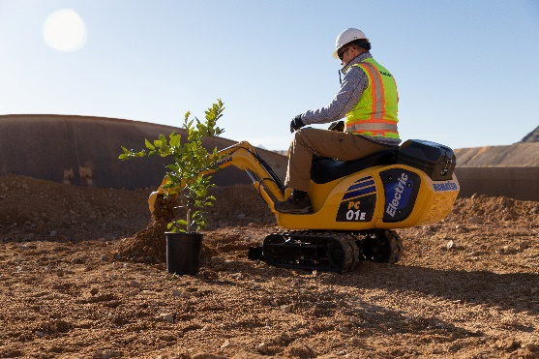To help customers reduce their carbon footprint and plan for sustainable solutions, including electrification, Komatsu will showcase a number of products including the **PC30E and PC210LCE electric excavators**, as well as the **PC01E electric micro excavator**. The booth will also highlight the company's **WA electric wheel loader concept** machinebased on the chassis of the Komatsu WA70 wheel loader, as well as **battery technology and charging advancements**. The PC210LCE, PC30E and PC01E will be available in select markets in 2023.

Komatsu's PC01E electric micro excavator, developed jointly with Honda, is powered by portable and swappable mobile batteries.

To support the company's One Komatsu global mining strategy, sizers, reclaim feeders and surface feeder breakers will be rebranded to Komatsu yellow (from Joy orange). Displayed in the booth will be the newly **rebranded Komatsu MVT-II 600 crusher**, which consumes less energy than compression crushing methods, minimizes fines and reduces waste.

**Integrated solutions to explore:**

At the booth’s service and support tower and throughout the equipment on the floor, customers can learn about a variety of services Komatsu offers to support equipment, job sites and overall operations. **My Komatsu**, an all-encompassing customer portal, provides complimentary and convenient access to a customer’s fleet and all the information needed to manage their operations. Mixed-OEM telematics data, warranty coverage, publications, oil samples and online parts ordering enable customers to make critical business decisions 24/7. Customers can use My Komatsu’s new alerts feature to make sure nothing falls through the cracks and learn and subscribe to the newest technology solutions available from Smart Construction and Smart Quarry.

To help increase stakeholder profitability and strengthen workforces by improving operational efficiencies, **Komatsu Academy** is a new digital learning community focused on providing training needs virtually online, as a blended course offered online and in person at Komatsu’s state-of-the-art training facility – or at customer locations. Expert instructors offer operator, technical, service and technology training for equipment operation, maintenance and service.

Choosing Komatsu parts remanufactured to OEM specs enables customers to reduce costs without sacrificing quality. Backed by Komatsu's industry-leading warranty and assurance program, **Reman** is a sustainable and cost-effective option designed to give machines new life, at a fraction of the cost of new components.

**In-booth experiences:**

* Live presentations highlighting the latest challenges facing the construction and quarry industries, every hour starting at 9:30 a.m. each day of the show.
* [Exclusive photo opportunity with the crew of ***Hoffman Family Gold***](https://www.komatsu.com/en/events/conexpo/?utm_source=Komatsu&utm_medium=PressRelease&utm_campaign=ConExpo2023&utm_content=Hoffman-family-gold)**:** Todd and Jack Hoffman, along with some of their former *Gold Rush* crew, are relying on Komatsu equipment to mine in extreme conditions in remote Alaska. Todd, Jack and Hunter Hoffman, along with Andy Spinks, will be in the Komatsu booth at the following times for photo opportunities with attendees:
  + **Wednesday, March 15: 10-11:30 a.m. and 1:30-3 p.m.**
  + **Thursday, March 16: 10-11:30 a.m.**

**Educational seminar**

* On **Friday, March 17, 10:45 - 11:30 AM at West Hall, 206**, Komatsu’s Jason Anetsberger, Director of Customer Solutions, will present [Digital Transformation of the Job Site](https://directory.conexpoconagg.com/8_0/sessions/session-details.cfm?scheduleid=128), a session that will demonstrate how even small steps toward a digitally transformed job site can promote safety, help optimize production, lower costs and waste, and help attract and retain talent.

With the right products, latest technologies, actionable data and dealer support, Komatsu and its customers can create value together. To learn more, visit Komatsu at CONEXPO 2023 at booth W42044. Additional products and solutions will be highlighted at neighboring booths for Hensley Industries (W42028), and Montabert (W42229), both Komatsu subsidiaries.

For those unable to attend the show in person, Komatsu will be providing updated virtual coverage at <https://www.komatsu.com/en/events/conexpo/>.

**About Komatsu**

Komatsu develops and supplies technologies, equipment and services for the construction, mining, forklift, industrial and forestry markets. For a century, the company has been creating value for its customers through manufacturing and technology innovation, partnering with others to empower a sustainable future where people, business and the planet thrive together. Front-line industries worldwide use Komatsu solutions to develop modern infrastructure, extract fundamental minerals, maintain forests and create consumer products. The company's global service and distributor networks support customer operations to enhance safety and productivity while optimizing performance. To learn more visit [www.komatsu.com](http://www.komatsu.com)

###