

**Media support:**

Mason Raube

+1 920-517-7945

[mason.raube@global.komatsu](mailto:mason.raube@global.komatsu)

Komatsu to highlight drill and dozer teleoperation advancements

Komatsu is expanding automation and providing interoperable solutions to enable a new era of customer teleoperations

**September 24, 2024** — [Komatsu](https://www.komatsu.com/en/?utm_source=Komatsu&utm_medium=PressRelease&utm_campaign=MINExpo2024&utm_content=Dozer%20and%20drill%20teleoperation) is proud to announce two separate teleoperation advancements for its blasthole drills and mining dozers, further advancing mine safety, productivity and operational interoperability. These advancements mark a significant step toward the future of remote-controlled equipment, allowing operators to manage heavy machinery from an off-site location. By integrating innovative teleoperation technology into the core of equipment, Komatsu empowers customers to enhance productivity while prioritizing worker safety, particularly in high-risk environments.

**Blasthole drills: expanding the horizon with non-line-of-sight teleoperation**

Komatsu is excited to introduce a new capability within its drill automation package: non-line-of-sight drilling for the blasthole drill line, which will be showcased at MINExpo 2024. This breakthrough allows operators to remotely control drilling operations from off-site locations within the customer's network, offering increased flexibility and safety. Komatsu's drill automation technology is designed to reduce operational variability, leading to improvements in blasthole quality and fragmentation through precise execution of drill patterns. Customer benefits include more consistent production output, reduced machine wear from less experienced operators and improved downstream process efficiencies.

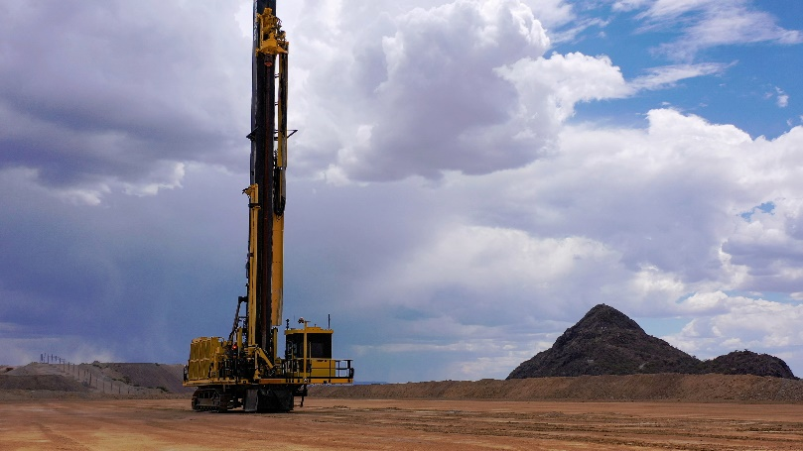"Komatsu's drill automation technology portfolio is designed to provide flexibility and support our customers' growing need for remote and autonomous drilling. Non-line-of-sight teleremote operation is our next exciting offering, expanding upon our existing capabilities to provide more operational freedom, safety and productivity," said Jesse Dubberly, Vice President of Surface Drilling at Komatsu.

*A Komatsu ZR77 blasthole drill at the company’s Arizona Proving Grounds*

For a firsthand look at the non-line-of-sight technology and its capabilities, visit Komatsu at booth 7132 in Central Hall at the Las Vegas Convention Center from September 24 to 26 for a live demonstration on the main stage. The demonstration will feature live teleoperations with an operator in Las Vegas and a machine in Arizona.

**Teleoperation dozers: revolutionizing safety and productivity in harsh environments**

Komatsu is equally excited to announce the latest teleoperation technology for its mining dozers, which will be showcased at MINExpo 2024. This technology integrates Modular ProVision machine guidance with automatic blade control, offering precise and reliable remote operation, even in the most hazardous environments, such as stockpiles and ripping applications. Komatsu teleremote dozers, which have already seen successful deployments in Brazil and Australia, allow operators to maintain productive operations from a distance without sacrificing control or efficiency.

This advanced system eliminates the need for operators to endure high-risk conditions, including high-vibration environments. By leveraging the automatic blade control technology, Komatsu has successfully mitigated the latency issues typically associated with teleoperation, ensuring consistent productivity without compromise.

Primary benefits identified at customer sites include the complete removal of operators from hazardous zones, increased production in high-risk environments and the opportunity for less experienced operators to reach proficiency in a shorter time period. In addition, teleoperation offers training capabilities directly at the console and reduced downtime for shift changes or breaks. Komatsu's continued innovation in teleoperation throughout mining operations demonstrates dedication to driving safer and more productive operations for customers.

*A Komatsu D375A-8 teleremote mining dozer*

For a firsthand look at Komatsu’s teleoperation mining dozers and their capabilities, visit Komatsu at booth 7132 in Central Hall at the Las Vegas Convention Center from September 24 to 26 for a live demonstration on the main stage.

**About Komatsu**

Komatsu develops and supplies technologies, equipment and services for the construction, mining, forklift, industrial and forestry markets. For more than a century, the company has been creating value for its customers through manufacturing and technology innovation, partnering with others to empower a sustainable future where people, business and the planet thrive together. Front-line industries worldwide use Komatsu solutions to develop modern infrastructure, extract fundamental minerals, manage forests and create consumer products. The company's global service and distributor networks support customer operations to help enhance safety and promote productivity while working to optimize performance. Learn more at [www.komatsu.com](http://www.komatsu.com).

# # #