

**Media support:**

Mason Raube

+1 920-517-7945

[mason.raube@global.komatsu](mailto:mason.raube@global.komatsu)

**Komatsu to feature the Joy 12HM26 continuous miner at MINExpo**

Joy offers a portfolio of heavy miners to meet customer's industrial mineral applications

**September 24, 2024 —** [Komatsu](https://www.komatsu.com/en/?utm_source=Komatsu&utm_medium=PressRelease&utm_campaign=MINExpo2024&utm_content=Industrial%20minerals) will showcase the Joy 12HM26 continuous miner at MINExpo, an example of its product offerings designed to meet the unique needs of the industrial mineral sector. The 12HM26 is part of a family of heavy miners (HM) designed and built for harsh conditions and enhanced with powerful automation features.

With a total mass of more than 95,000 kg and boasting 750 kW of total power, the 12HM26 is engineered specifically for [industrial mineral applications](https://www.komatsu.com/en/industries/industrial-minerals-mining/?utm_source=Komatsu&utm_medium=PressRelease&utm_campaign=MINExpo2024&utm_content=Industrial%20minerals). Equipped with an advanced Ripperveyor cutting system, this machine delivers exceptional power, durability and operational flexibility.

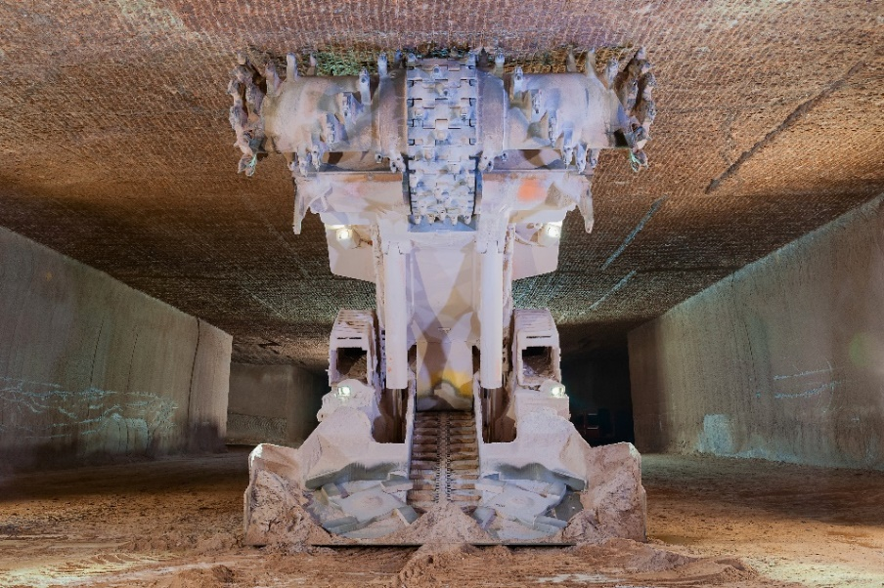Global demand for industrial minerals continues to rise, and Komatsu is strategically positioned to support the growing need for efficient, sustainable mining solutions. The 12HM26 is one machine in a robust lineup of Joy branded equipment tailored for underground soft rock mining. Komatsu's Director of Business Development, Jim Haughey, emphasized the company's commitment to this expanding sector.

*A Joy 12HM46 continuous miner underground in a salt mine*

"At Komatsu, we've been delivering innovative mining solutions for more than 100 years," said Haughey. "The family of Joy 12HM continuous miners is a testament to our dedication to providing equipment that meets and exceeds the rigorous demands of the industrial minerals market. They are powerful, flexible and equipped with advanced automation technologies prioritizing productivity and enhancing safety."

Joy HM solutions, such as the 12HM26, are designed to enhance operational efficiency through their all-electric operation, which reduces environmental impact and extends component life cycles. A primary feature of the machines is the integration of automation technologies that support remote management and operator assistance for underground operations. In line with Komatsu's sustainability goals and commitment to zero harm, the 12HM26 can be equipped with a proximity detection system with dynamic zones that interact seamlessly with manual operations, boosting safety and efficiency.

For a firsthand look at the Joy 12HM26 continuous miner and other advanced mining solutions, visit Komatsu at booth 7132 in Central Hall at the Las Vegas Convention Center from September 24 to 26.

**About Komatsu**

Komatsu develops and supplies technologies, equipment and services for the construction, mining, forklift, industrial and forestry markets. For more than a century, the company has been creating value for its customers through manufacturing and technology innovation, partnering with others to empower a sustainable future where people, business and the planet thrive together. Front-line industries worldwide use Komatsu solutions to develop modern infrastructure, extract fundamental minerals, manage forests and create consumer products. The company's global service and distributor networks support customer operations to help enhance safety and promote productivity while working to optimize performance. Learn more at [www.komatsu.com](http://www.komatsu.com).

# # #