

**Media support:**

Mason Raube

+1 920-517-7945

[mason.raube@global.komatsu](mailto:mason.raube@global.komatsu)

Komatsu launches interoperable mine management platform

*Modular ecosystem designed to unlock new value for mining operations*

**Sept. 24, 2024** — Building upon its industry-leading DISPATCH fleet management system, Komatsu is excited to announce the launch of the new [Modular ecosystem](https://www.komatsu.com/en/technology/smart-mining/modular/?utm_source=Komatsu&utm_medium=PressRelease&utm_campaign=MINExpo2024&utm_content=Modular%20ecosystem), an expanding set of interconnected platforms and products designed to simplify existing workflows while creating a bold vision for the future of mine site optimization and data utilization.

Through interactive displays and demonstrations at Komatsu’s booth at MINExpo 2024 this week in Las Vegas, the global equipment and solutions provider is giving attendees a chance to be part of the public unveiling of their connected system approach.

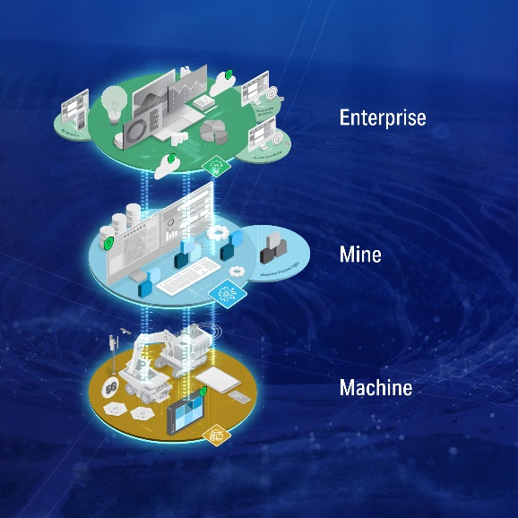“One of our customers’ biggest challenges is being able to get the full value out of the data sets they own,” said Jason Fletcher, Senior VP of Mining Technology Solutions at Komatsu. “The Modular ecosystem is that entry point for a mine operation to have one place to gather operational information for every activity that's going on across their mine site. It’s our path forward to help optimize mining operations at the machine, mine site and enterprise levels.”

Thanks to its open architecture design, the Modular ecosystem offers customers the ability to create a “single source of truth” for common data used across their mining operations, including data from connected Komatsu products as well as third-party vendors and other connected equipment. Access to all connected operational data allows customers to streamline decision making and support remote decision making. The Modular ecosystem will also allow stakeholders to securely share their data with partners of their choice, fostering collaboration and increasing overall solution velocity for an industry in the midst of ongoing transformation to meet the needs of a more sustainable future for all.

A visualization of the Modular ecosystem bringing together data from all levels of mining operations.

The first new offerings on display at the show include four apps to simplify existing DISPATCH workflows, introduce new technology and help customers prepare for an optimized experience. Now available for customer demos with commercial release on the horizon are:

* Simulate – visualize and analyze scenarios to improve decision making across the shift
* Roadways – keep road systems up-to-date with little user intervention
* Replenish – refuel and recharge mining equipment while minimizing impact to production
* Look Ahead –execute multi-objective mine plans and take optimization to the next level

To learn more, visit Komatsu at booth 7132 in Central Hall during MINExpo, Sept. 24-26, 2024.

**About Komatsu**

Komatsu develops and supplies technologies, equipment and services for the construction, mining, forklift, industrial and forestry markets. For more than a century, the company has been creating value for its customers through manufacturing and technology innovation, partnering with others to empower a sustainable future where people, business and the planet thrive together. Front-line industries worldwide use Komatsu solutions to develop modern infrastructure, extract fundamental minerals, manage forests and create consumer products. The company's global service and distributor networks support customer operations to help enhance safety and promote productivity while working to optimize performance. Learn more at [www.komatsu.com](http://www.komatsu.com).

# # #