

D475A-8 surface mining dozer

*Media fact sheet*

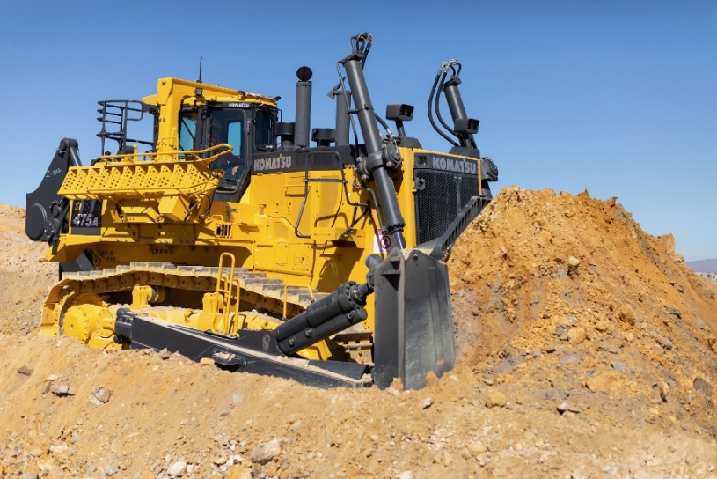Built for years of reliable service, the Komatsu D475A-8 has a dependable mainframe to target twice the life of previous models and withstand multiple rebuild/overhaul cycles. Its low center of gravity provides stability, and its long and consistent track on ground length offers more traction, pushing power, ripping efficiency and less shoe slippage, while its high horsepower in reverse means the lock-up converter stays engaged more frequently, allowing significantly higher levels of production, especially when pushing down slopes.

The D475A-8 surface mining dozer targets twice the life to withstand multiple rebuild/overhaul cycles.

The redesigned undercarriage significantly reduces shock and vibrations when traveling over rough terrain, while the ergonomic ripper control lever incorporates an auto-return function designed for less fatiguing operation, automatically raising the ripper after momentarily actuating the control lever while the machine is in reverse.

Engineered to minimize planned downtime and make maintenance efficient, the D475A-8 has centralized greasing points, ground-level fill/evac service center and battery and

starter isolators with lockout tagout functionality. Outstanding operator visibility to the ripper shank and a rearview monitoring system help add situational awareness.

**Quick specs**

* Operating weight: 115,300 kg (254,195 lbs.)
* Net horsepower: Forward – 664 kW @ 2,000 rpm (890 HP @ 2,000 rpm)
* Net horsepower: Reverse – 722 kW @ 2,000 rpm (968 HP @ 2,000 rpm)
* Blade capacity: 27.2-45.0 m3 (35.6-58.9 yd3)

**Quick benefits**

Compared to the previous model, the D475A-8 offers:

* Up to a 10% productivity increase
* 11.5% more net engine power in reverse, compared to forward direction
* 10% reduction in fuel consumption with automatic transmission with lockup torque

converter compared to manual gearshift operation