

D71PXi-24 dozer

*Media fact sheet*

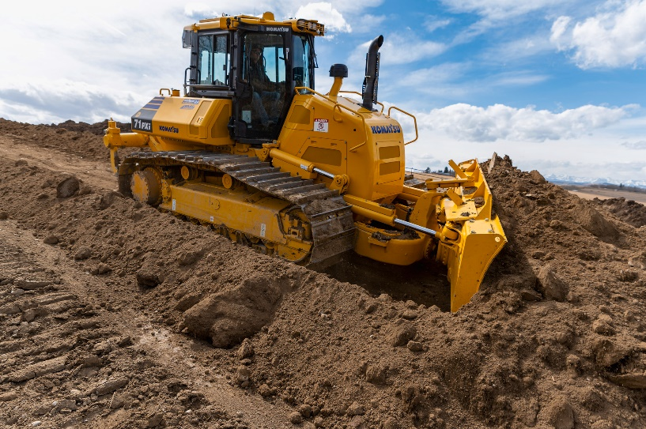The most powerful HST dozer in its size class, the D71PXi-24 offers an array of innovations: its distinctive slant nose design for exceptional visibility; a Parallel Link Undercarriage System (PLUS) that features rotating bushings to help minimize maintenance downtime and cost of ownership; and Intelligent Machine Control 2.0 (IMC 2.0).

The powerful D71PXi-24 features a slant nose design for exceptional visibility as well as all of the features of Komatsu’s Intelligent Machine Control 2.0.

Designed to wear evenly so the machine provides close to 100% usage of undercarriage components, Komatsu PLUS undercarriage lowers undercarriage maintenance costs by up to 40% compared to a conventional undercarriage, while strengthened rollers and links increase wear life up to two times.

With Komatsu’s IMC 2.0 the D71PXi-24

* Learns as it works with *proactive dozing control*. The dozer measures the terrain it tracks over and uses that data to plan the next pass so even less experienced operators can automatically cut/strip from existing terrain to improve productivity by up to 60%, compared to the previous generation of machine control.
* Automatically lets operators spread fill from existing terrain with the press of a button with *lift layer control*. The dozer measures the terrain it tracks over and uses the data for consistent layers for compaction quality.
* Automatically tilts the blade to maintain straight travel during rough dozing (*tilt steering control*) reducing operator steering input by up to 80%.
* Enables operators to create a temporary design surface with the press of a button with *quick surface creation*. Combined with other IMC 2.0 functions, crews can begin stripping or spreading using automated input while waiting for the finish grade model.

IMC 2.0 has a two-antenna system that supports multiple GNSS, for less downtime and more work time.

**Quick specs**

* Net horsepower 237 HP (177 kW) @ 2,100 rpm
* Operating weight 51,147 lbs. (23,200 kg)
* Blade capacity 6.1 yd3 (4.65 m3)