

GD955-7 motor grader

*Media fact sheet*

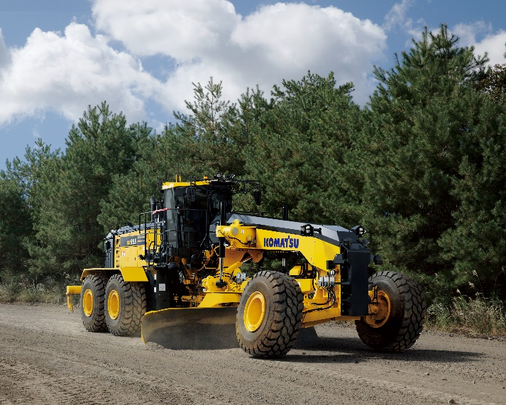

The GD955-7 is designed to build and maintain haul roads for 100 ton and up haul truck fleets.

Featuring an 18-foot moldboard (with an optional 20-foot), the GD955-7 motor grader is designed to build and maintain haul roads for haul truck fleets 100-tons and higher. This motor grader offers ample horsepower for efficient grading and leveling performance to enhance productivity. The newly adopted circle bearing eliminates the need for circle guide and wear plate adjustments, reducing maintenance downtime.

With a long wheelbase and a high operating weight, the GD955-7 can increase its blade-down force pressure for penetrating hard packed haul road surfaces. The GD955-7’s large size does not compromise maneuverability. This motor grader can execute tight U-turns on a standard 100 ton class haul road without needing to fully cut the wheels or course correct.

**Quick specs**

* Horsepower: 426 HP @ 1900 RPM
* Operating weight: 104,323 lbs.
* Moldboard: 18-foot standard, 20-foot optional

**Comparison to prior model**

* Up to 33% increase in productivity with 18-foot moldboard
* Up to 46% increase in productivity with 20-foot moldboard
* 32% higher engine output for up to 19% higher working travel speeds
* Up to 20% increase in available moldboard down pressure
* Up to 21% reduction in total maintenance time with circle bearing system