

HB365LC-3 hybrid excavator

*Media fact sheet*

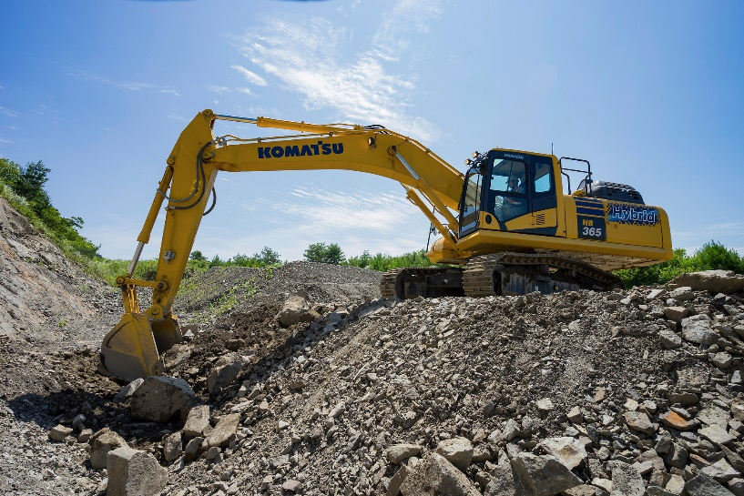For customers looking to manage energy transitions, increase efficiencies and reduce fuel burn and emissions, Komatsu's HB365LC-3 hybrid excavator is designed to provide high production and efficiency with low fuel consumption.

Komatsu's HB365LC-3 hybrid excavator is designed to provide high production and efficiency with low fuel consumption

Its generator/motor system provides an additional 70 HP on demand and up to 15% more productivity in P mode. The environmentally friendly operation of the HB365LC-3 can deliver up to 20% greater fuel efficiency but with 20% lower CO2 emissions.

This fourth-generation high-performance excavator is powered by a Komatsu hybrid electrical swing system that provides plenty of torque and acceleration for all excavating tasks, to help increase productivity while promoting carbon reduction. Its responsive swing system with improved swing acceleration helps improve cycle times. Whether on the slopes or in trenches, this machine is perfect for applications such as bulk material handling, loading crushers and concrete recycling, truck loading with 90-degree swing angles, and typical trenching when depth is less than 12 feet.

How the hybrid system works:

1. At the end of each swing cycle, the swing motor functions as a generator to recover excess kinetic energy, which is converted to electrical power and stored in a Komatsu ultra-capacitor.
2. Stored power from the ultra-capacitor can be sent to an engine-mounted motor-generator to provide immediate engine response from an ultra-low 700 rpm idle speed.
3. The hydraulic power normally needed by the swing system is now completely available for boom, arm and bucket power, helping to improve digging cycle time and production.

**Quick specs**

* Horsepower: 269 HP @ 1,950 rpm
* Operating weight: 81,791-85,495 lbs.
* Bucket capacity: 0.89-2.56 yd³

**Comparison to non-hybrid Komatsu excavators in the same class**

* Increases productivity by up to 15%
* Reduces fuel consumption by up to 20% (depending on application)
* Lessens CO2 emissions