

HD1500-8E0 mechanical haul truck

*Media fact sheet*

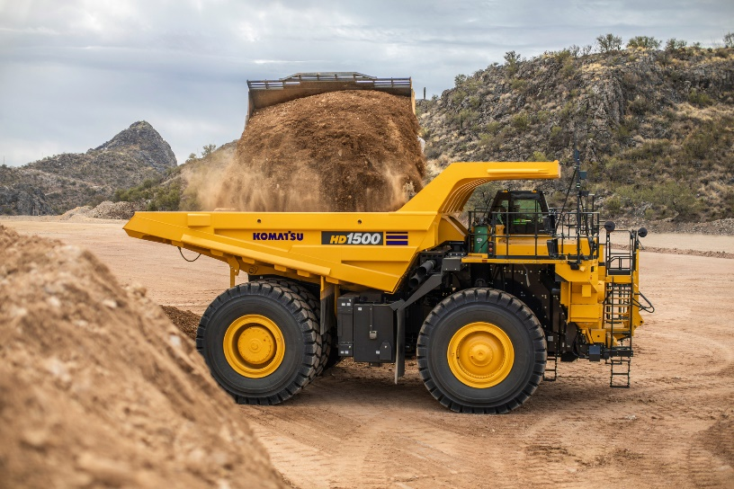Designed to deliver performance on grade while providing energy-saving technologies to help achieve lower fuel consumption, the HD1500-8E0 is equipped with hydraulic, wet multiple-disc brakes on all four corners. The continuously cooled, large-capacity brakes also act as a highly responsive retarder, providing operators with confidence at higher speeds when traveling downhill.

The HD1500-8E0 delivers performance on grade as well as energy-saving technologies to help lower fuel consumption.

With a tight turning radius (36' 9" /11.2 m) operators can easily maneuver in and out of tight spaces when spotting to be loaded or positioning to dump. The MacPherson strut-type independent front suspension features an A-arm wheel-to-mainframe design for wide spacing and easy access to the engine bay.

Komatsu’s Traction Control System (KTCS) provides excellent control in loose or slippery haul road conditions by monitoring the rear wheels for slippage and automatically applying pressure to the independent wheel brake assemblies.

The integrated payload meter manages the payload of each hauling cycle, analyzing production volume and the working conditions of the machine. For convenient preventative maintenance and servicing, the ground-level service center is located at the bottom of the truck‘s hydraulic tank, putting engine, transmission, brake control and hydraulic oil filling evacuation ports accessible in one central location.

**Quick specs**

* Net horsepower: 1,570 HP (1,171 kW) @ 1,900 rpm
* Rated gross vehicle weight: 550,229 lbs. (249,579 kg)
* Rated payload: 153.2 U.S. tons (139.0 t)
* Rated Capacity: (SAE Heaped 2:1): 102 yd³ (78 m³)

**Quick benefits**

* Robust V-shaped dump body design
* Four wet multiple-disc brakes to help ensure stable brake performance
* Performance on grade
* Tight turning radius
* Spacious and ergonomic cab