

PC2000-11 excavator

*Media fact sheet*

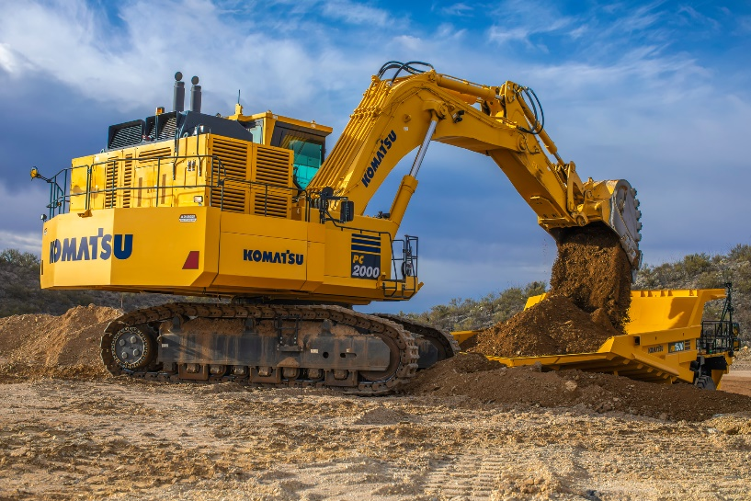Designed to load 70–150-ton haul trucks, the PC2000-11 is built for stripping applications or removing overburden from an ore seam. Its higher net horsepower enables increased pump absorption power, while its swing priority valve ensures swing speed is available when needed, to help improve cycle times.

The PC2000-11 is designed to withstand tough operations and load 70-150-ton haul trucks

To withstand tough operations, the revolving frame, center frame and crawler frame structures on this excavator are strengthened and the boom and arm are highly resistant to bending and torsional loads. The increased engine power, more efficient hydraulic system and engine-pump control logic provide faster cycle times and improve multifunction performance.

Operators have a 360-degree view of the surrounding work area on a dedicated 10.4-inch LCD monitor, and the standard KomVision seven-camera system helps improve situational awareness.

To help minimize downtime and boost production, major components are located within the power modular, which can be quickly removed and replaced or rebuilt. Ground-level service, centralized for fuel, oil, greasing and coolant, hydraulically raises and lowers at the rear of machine.

**Quick specs**

* Operating weight: 201,930-207,258 kg (445,179- 456,926 lbs.)
* NET Horsepower: 780 kW @ 1,800 rpm (1,046 HP @ 1,800 rpm)
* Bucket capacity: 12.0-13.7 m3 (15.7- 17.9 yd3)

**Comparison to prior model**

* Up to 11% faster cycle times
* Productivity increase of up to 12%
* 9% more available engine horsepower