

PC900LC-11 excavator

*Media fact sheet*

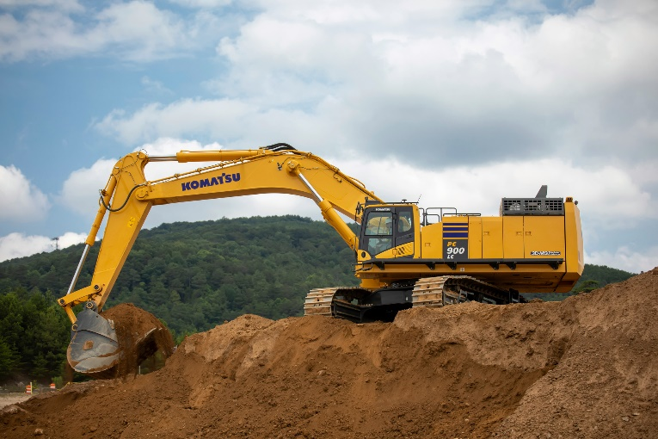A powerful, purpose-built machine engineered for tough jobs that require high performance, this 90-ton excavator is versatile and designed for easy transport between job sites. High engine performance and enhanced hydraulics technology promote reliability, while offering the benefits of customization with various boom and arm configuration options.

The 90-ton PC900LC-11 offers convenient transportability with a removable counterweight and a lowered boom height option.

Combining high-performance capabilities with impressive digging force designed for fuel-saving efficiencies, the PC900LC-11

* Offers convenient transportability with a removable counterweight and a lowered boom height option
* Ease of maintenance with centralized service points and easy access to components
* Enhanced performance with a wide range of bucket size choices

The KomVision camera system helps enhance visibility, mitigate blind spots, promote job site safety and enable operators to maneuver equipment with confidence.

Optional Smart Construction 3D guidance and payload monitoring system can help optimize loads, promote improved accuracy and reduce rework, and prevent overloading/underloading.

**Quick specs**

* Engine power: 543 HP (405 kW)
* Operating weight: 204,148 lbs. (92,600 kg)
* Bucket capacity: 3.7-8.0 yd3 (2.8-6.1 m3)

**Comparison to the prior model**

* 10% more engine HP
* 11% stronger bucket digging force
* 48% more productivity (more HP, larger bucket and better hydraulics increase cycle times)
* 40% more efficiency (with the Tier 4 engine and enhanced hydraulic circuits)