

Stamler RF-5Q reclaim feeder

*Media fact sheet*

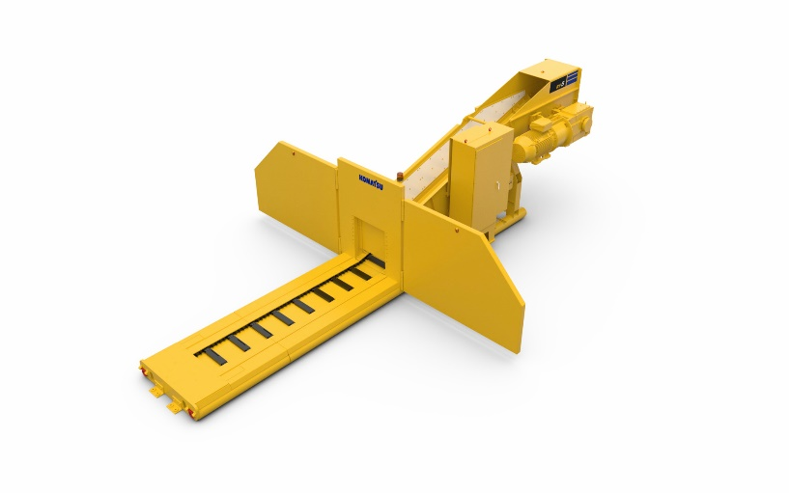Offering flexibility and lower TCO, with Stamler reclaim feeders materials can be fed and blended with smooth operation and minimal maintenance.

Leveraging the same parts and components across the product line, the Stamler RF-5Q reclaim feeders offer flexibility and lower TCO.

Featuring simple machine architecture, these feeders reduce installation and shipping fees, providing savings from the start. By leveraging the same parts and components across the product line, they deliver a more cost-effective operation and help contribute to uptime. Pre-engineered solutions include provisions for bolt-on/plug-in options and the spliced frame for intake extension does not require welding.

Easily moved and installed (only requiring solid, level ground and a power source), Stamler reclaim feeders work hard in cement plants, ports, refineries, power plants and mines. They can blend and feed a wide range of materials including coal, aggregates, limestone, petroleum coke, clay, iron ore, mill scale, bauxite, clinker, fly ash, tire chips and gypsum.

Heavy-duty steel components contribute to machine longevity, while the low-profile beveled intake end reduces damage from loading equipment. The engineered class chain accommodates both fine and sticky materials without compromising productivity.

The thoughtful feeder design offers electrical protection with emergency stops, covers, guards and screens to eliminate operator contact with moving parts. Frame stabilization, automatic operation and low speed options further contribute to a safer operating environment. Electric automatic lubrication saves time, while remote operation from the Machine Control Center (MCC) increases efficiency and safety.

**Quick specs**

* Overall width 2304 mm (7' 7")
* Conveyor width 914 mm (36")
* Overall length 12090 mm (39' 7")
* Mass weight 21,000 kg (46,200 lbs.)
* Power rating (baseline) 150 kW (200 hp)