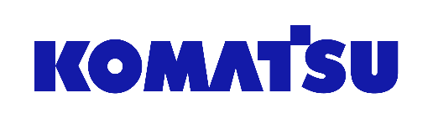

Smart Quarry solutions

*Media fact sheet*

To help enhance predictability and optimize production, Komatsu has developed technologies that can lead to smarter decisions for businesses in the quarry industry.

Brand-agnostic, Smart Quarry Site is a site management tool that focuses on fleet production, health and safety.

Successful projects depend on robust data that is easily shared, replicated and updated. Komatsu’s Smart Quarry consultants assess job site needs and recommend the best fleet to help customers meet current and future production goals. By connecting customers with the right digital tools to better understand, track and optimize mobile equipment, Smart Quarry advisors can help lower unit costs and improve the bottom line.

Their job is to understand quarry’s challenges and goals, and then connect customers with digital solutions to help them get the most out of their equipment and operators.

Smart Quarry Site

* This brand-agnostic site management tool focuses on fleet production, health and safety. Real-time monitoring via the cloud helps provide an in-depth understanding of production, fuel consumption, idle time, utilization and operator performance.

Smart Quarry Study

* Komatsu's Smart Quarry experts can analyze a site to help determine the most efficient mobile fleet to meet project targets. Custom reports provide vital details such as machine size, machine configuration, and fleet size.

Identifying opportunities that lead to growth is critical for any business. Whether in-person or remote, Komatsu’s Smart Quarry application engineers can provide in-depth analysis and discuss the key factors (fleet production and fuel analysis) that will help execute operational objectives and drive progress.

**Komatsu's Smart Quarry experts can help customers by**

* Selecting the right-sized equipment based on production analysis
* Configuring cost per ton (or yard) of material moved
* Producing data reports that are valuable, understandable and shareable
* Finding brand-agnostic solutions that serve business needs