

WA475-10 yard loader

*Media fact sheet*

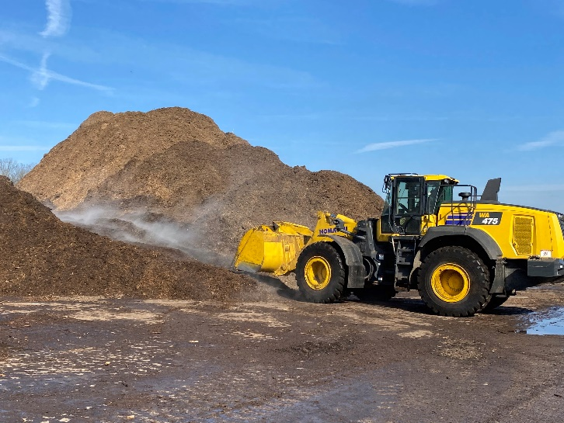Designed for simplified operation with independent work equipment control and a fuel efficient powertrain, the 290 horsepower Komatsu WA475-10 yard loader is purpose-built for loading on highway trucks with processed material in quarry, mining, and aggregate applications.

The WA475-10 yard loader offers a larger bucket and the 1,036 pounds of additional counterweight provides increased stability.

With curved side edges, the Komatsu-designed, 6-cubic-yard bucket is built to minimize spillage, and the internal space and shape provides smooth material flow. The feature-packed integrated load meter system enables operators to monitor productivity in real-time, while the Komatsu Hydraulic Mechanical Transmission (KHMT) optimizes travel acceleration, traction force, work equipment performance, and allows the machine to maintain a lower, more constant engine speed.

For increased bucket capacity and stability, the yard loader arrangement has a 1,036 pounds of additional counterweight (compared to the standard WA475-10). Further stability is provided by low-profile tires with increased ground contact that are mounted to the standard heavy-duty front and rear axles.

Additional productivity features include excellent visibility to the pile and surroundings, an easy-to-operate Advanced Joystick Steering System (AJSS) and a comfortable air-suspension seat.

**Quick specs**

* Net horsepower 290 HP @ 1,600 rpm
* Operating weight 60,400 lbs.
* Bucket capacity 6.0 yd³

**Comparison to previous model**

* Up to 30% more fuel efficient
* Has 8% more breakout force
* Has 20% more boom lift force