

WA900-8 wheel loader

*Media fact sheet*

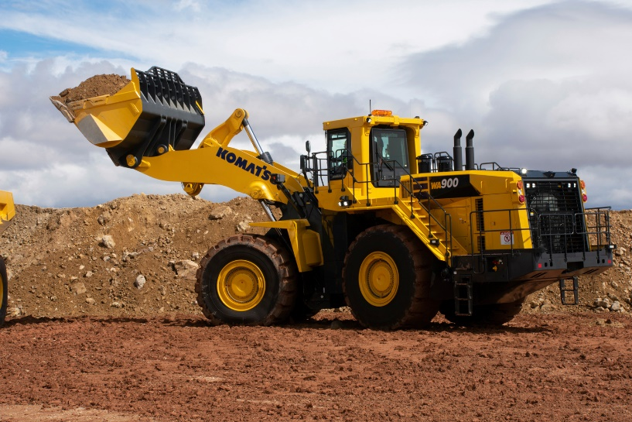Designed for performance and operator comfort, the WA900-8 can load 70- to 150-ton haul trucks. With a reinforced z-bar loader linkage, this wheel loader provides excellent breakout force and can help maintain productivity, especially when V-cycle loading haul trucks. Its three automated features automatic dig, semi-auto approach and semi-auto dump help alleviate operator fatigue and improve efficiency.

The WA900-8 provides excellent breakout force to help maintain productivity.

To help prevent tire slippage and increase tire life, the variable traction control system is designed to help operators maintain traction in slippery or wet conditions because machine rim pull can be infinitely adjusted between 100% and 20% tractive effort, depending on ground conditions. With 22 LED lamps, operators have enough bright lighting to maintain visibility, even in tough or dark working conditions.

Komatsu's SmartLoader Logic helps reduce fuel consumption while maintaining machine performance. This engine control system senses the power requirement of each work phase and automatically changes between 'Economy' and 'Power' mode based on the application's demand.

**Quick specs**

* Horsepower: 899 net HP @ 2,050 rpm
* Operating weight: 256,618 lbs.
* Bucket capacity: 15-19 yd3

**Comparison to previous model**

* Up to 17% more fuel efficiency
* Up to 9% more productivity
* 5% increase in net horsepower