

ZT44 track drill

*Media fact sheet*

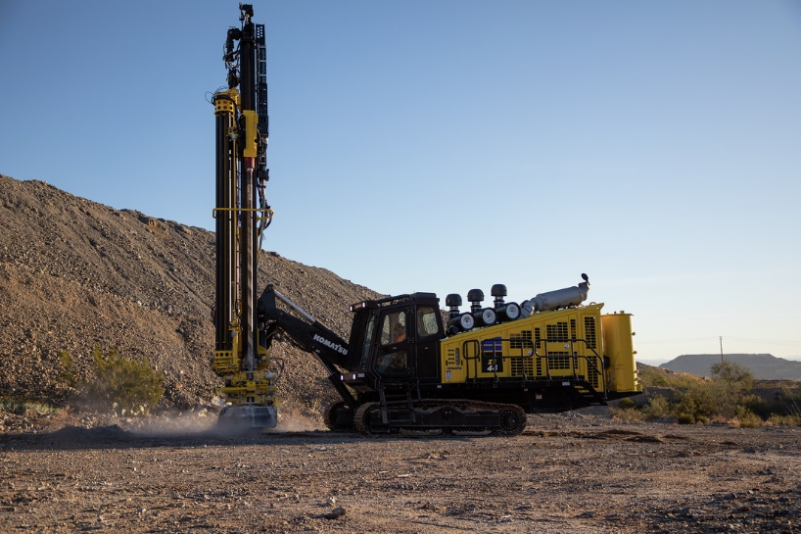Offering flexibility for use in a variety of patterns, applications and ground environments, the ZT44 track drill is designed to handle extended periods of drilling in the most extreme environments.

Built for longevity, production and reliability, the ZT44 delivers exceptional drilling in challenging rock conditions and high altitudes.

Built for longevity, production and reliability, the ZT44 has 50,000 lbf tractive force for agile maneuverability. Its high horsepower engine and high-pressure compressor deliver exceptional drilling in challenging rock conditions and high altitudes, while its cooling package layout ensures proper engine, compressor and hydraulic heat mitigation in a variety of environments.

The dual-pressure setting air compressor enables high- or low-pressure drilling for desirable penetration rates regardless of geology. Engineered for durability, the structures and components of the ZT44 are designed for demanding mining environments, with a target life of 40,000 hours.

From traditional presplit drilling to auxiliary function and even dewatering, the ZT44 offers flexibility. While its engine and compressor capacity match that of competitive platform-style rigs, its smaller footprint enables it to get into tight locations for a variety of drilling — from production to specialty.

**Quick specs**

* Horsepower 800 HP (596 kW) @ 2,100 rpm
* Compressor 1,360 CFM @ 350 psi
* Hole range 5.5 - 8.5 in